Prospective New Member  HOA Community Solutions  Gig Harbor, Washington | 
Last Updated: Dec 13, 2024 by Jacob Teich

Deal Overview
tl;dr
- Thesis: Acquire a growing, founder-owned management company in the Seattle metro area with very high customer retention rates
- Key stats (TTM 7/31/24):
  - $4.1M PF Rev & $856K PF EBITDA (21% margin)
  - 187 CAs, 21.1K doors, 34 FTEs
    - Estimated 60% HOA / 40% Condo Association
  - 3-yr retention: 99% door, TBD% logo, TBD% employee
  - CAM Cut: 44%
  - Revenue Mix: 72% Mgmt fee, 10% Transfer fees, 9% addendum fees, 9% bank earnings credits
- Opportunities / Growth:
  - Improve earnings credit agreement with Alliance (receiving ~$40K / month currently)
  - Create a sales and marketing function to accelerate growth (only referrals today)
- Considerations / Risks:
  - Founder transition from Juanita who has run the company for 17 years; it does not seem like there is a clear successor within the company today (PF EBITDA assumes we need to hire a new MCP)
  - Software transition to Vantaca is ongoing (rolled out to customers on Nov 1); no customer churn as of yet but seller mentioned that she is noticing some tension with certain associations
- Software and Banking:
  - Client Accounting: Vantaca (recent transition from VMS, work still ongoing to fully transition)
  - Corporate Accounting: Vanataca
  - Transfer & Resales: HomeWise
  - Payroll: QuickBooks
  - Client Banking: Alliance
- Transition Plan:
  - Roles
    - Juanita Carbaugh is the current owner / president who is looking to sell her business and transition out over a ~2-year period
    - Her husband is 20-years older than her, and she wants to spend more time with him
  - Who is there now that won’t be there post-close?
    - Juanita is transitioning out and but believes that there are 2 potential people within the company that could step into the MCP role
    - Senior accountant is also retiring in Q1’25
- Other relevant info:
  - HOA Community Solutions Data Room
  - HOA Community Solutions Info Sheet
  - HOA Community Solutions Pre-LOI Databook
  - HOA Community Solutions Info Call
  - HOA Community Solutions PD Call
- Recommendation:
  - Propose an LOI for an MC opportunity structured as:
    - $5.8M EV @ Closing (7.0x PF EBITDA)
      - $4.8M Cash at Closing
      - $1.2M Seller Note
      - 2026 earnout paying 8.0x any incremental EBITDA above $1.3M
    - Juanita indicated that she wants to receive a significant portion of proceeds over a longer period of time (for tax reasons) so we’ve incorporated a larger seller note

Transaction overview

HOA Community Solutions, based in Gig Harbor, WA (Seattle metro area, near Tacoma) is an association management company with 34 employees serving 188 CAs and 21K units. The portfolio is approximately 60% HOAs and 40% condo associations. The Company is 100% owned by Juanita Carbaugh who founded the Company in 2008. Juanita is looking to sell the Company and transition to retirement over the next two years. TCC has developed a relationship with Juanita through multiple conversations over the last year including in-person meetings at conferences. We believe that Juanita has had conversations with a few other potential buyers recently. Transaction Details
Preliminary Underwriting EBITDA and Valuation (Member Company)
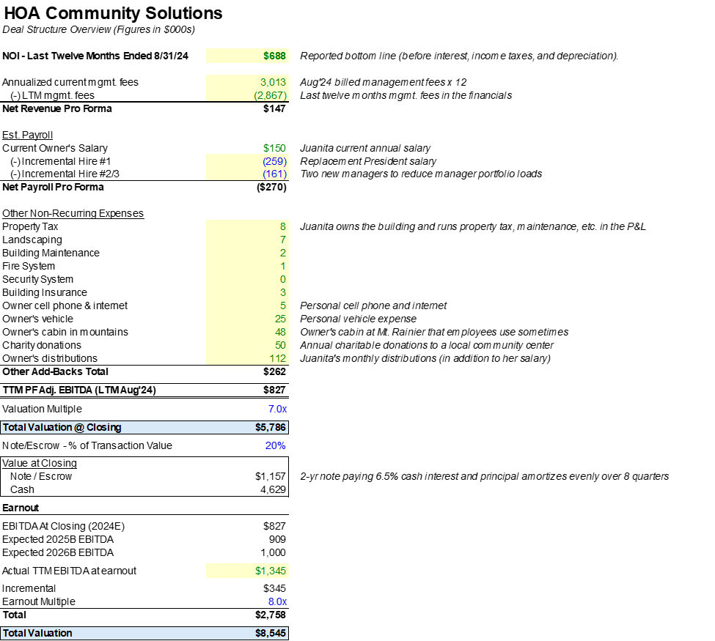

Commentary:

PF EBITDA: We assume that Juanita (who owns the building) will sign a long-term lease with TCC at the same rent rate that the Company is currently paying. We are also adding back identified personal expenses running through the P&L. Assume we need to hire a new MCP and two new managers.

Valuation: 7.0x PF EBITDA at closing ($5.8M EV @ Close) with 20% in a seller note. Similar in terms of scale to Creative and Hales which were both purchased for around 7x EBITDA.
Seller Note: 3-year term with a 6.5% interest rate. The principal will amortize evenly over 3 years so that Juanita can receive her proceeds over an extended period of time (per her request) and pay quarterly interest payments.

Earnout: 2026 earnout paying 8.0x any incremental EBITDA above $1.0M which is 10% growth p.a. from the current PF EBITDA.

Employment Agreement: Juanita would sign a 1-year employment agreement and then an hourly contractor agreement after that (similar to what we did with Doug at PAMco).

Source: HOA Community Solutions Pre-LOI Databook

Customer Retention Analysis
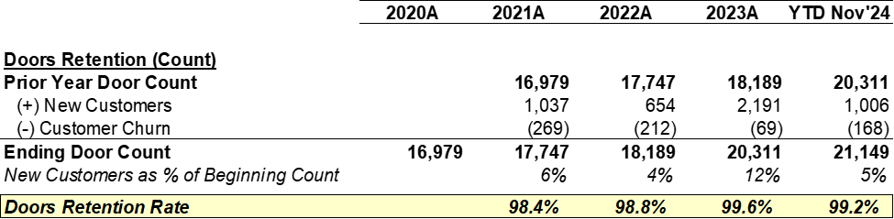

Commentary:

HOA Community Solutions has best-in-class customer retention based on data provided to date. They try to limit CAM load to 1,200 doors / manager. Juanita indicated that they are very focused on customer service and very rarely lose customers (1-2 clients churn per year out of nearly 200 associations).

Source: HOA Community Solutions Pre-LOI Databook

Employee Breakdown
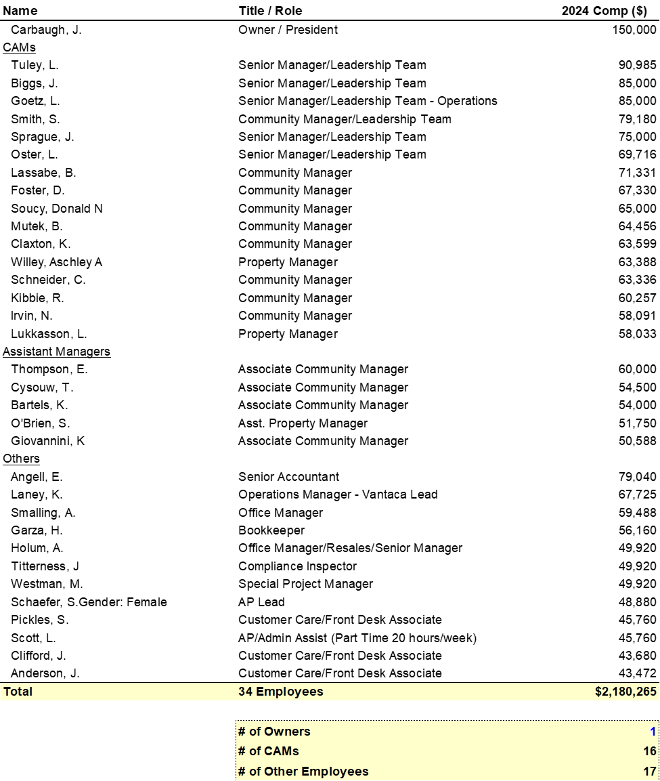
Commentary:

34 total employees including 16 community managers, 5 assistant managers, and 12 other staff members (accounting, office manager, inspector, etc).

Source: HOA Community Solutions Pre-LOI Databook

MC Benchmarking
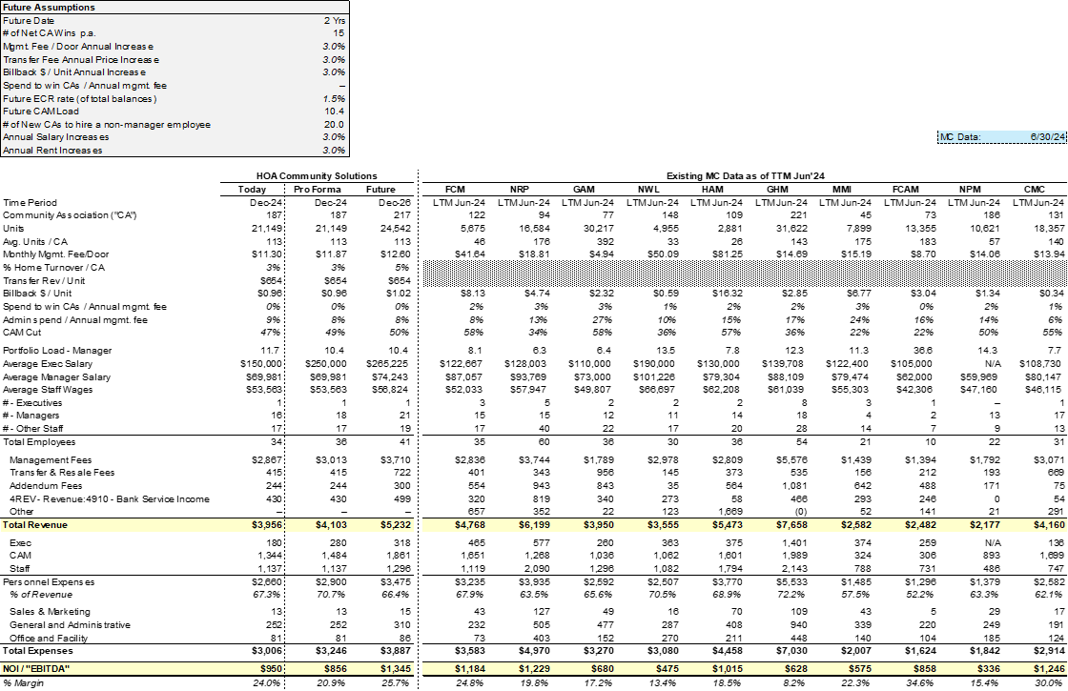

Source: HOA Community Solutions Pre-LOI Databook

Commentary:
All financials exclude the owner's personal expenses. The pro forma column assumes that we replace Juanita with a new MCP (at the same $150K salary, $180K including benefits).

